Practical No. 1

Aim: To implement Basic SQL commands and to access & modify Data using SQL. Create and populate a database using Data Definition Language (DDL) and DML Commands.

Theory:
Structured Query Language (SQL) is a powerful domain-specific language used for managing and manipulating relational databases. It consists of two main categories of commands: Data Definition Language (DDL) for defining the structure of the database, and Data Manipulation Language (DML) for interacting with the data stored in the database. In this document, we will delve into the implementation of basic SQL commands to create and populate a database using DDL and DML commands, while also discussing key concepts and best practices.

DDL commands are used to define, modify, and manage the structure of a database, including tables, indexes, and constraints. Some key DDL commands are:
CREATE, DROP, ALTER, TRUNCATE, SELECT

DML commands are used to interact with the data stored within the database. They include commands for inserting, updating, and deleting data, as well as querying data for retrieval.
Some key DML commands are:
UPDATE, INSERT, DELETE

Queries:

1) Change the price of “plate” from 1500 to 2000.
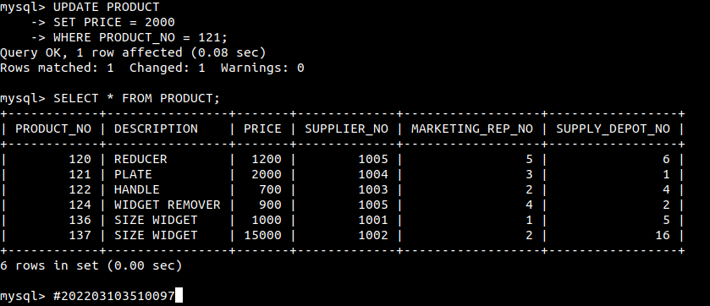

2) Modify the credit limit to 8000 for those customers who live in “Grange”.
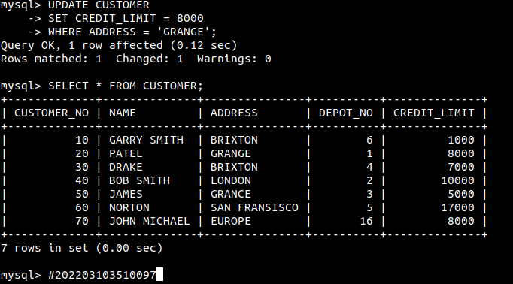

3) Change the size of the customer address to 30.
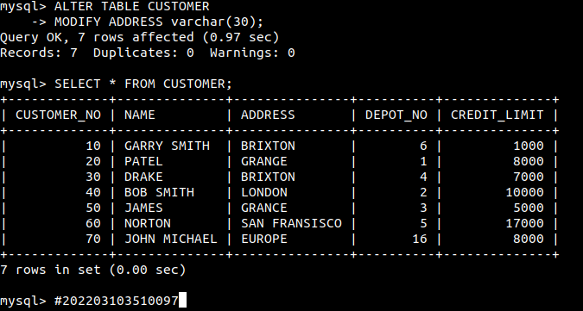

4) Create a table cust1 with the attributes and formats
Customer_no number (10)
Name varchar2 (20)
Address varchar2 (20)
Rep_no number (10)
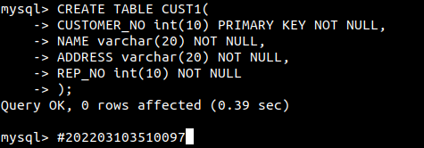

5) Add a new field email id in the cust1 table.
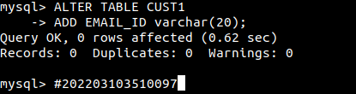

6) Display the structure of the cust1 table.
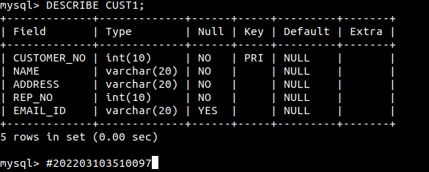

7) Display the content of the cust1 table.
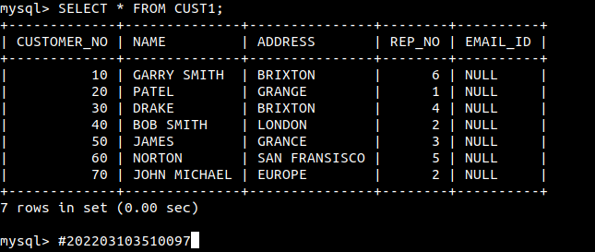
8) Delete details of customer no 2 from cust1 table.
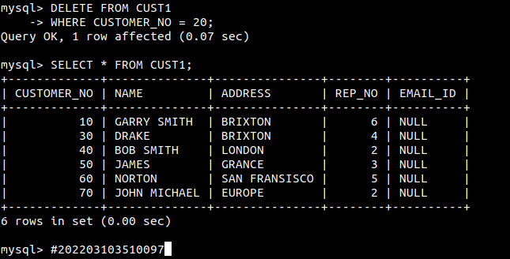

9) Delete email id field from cust1 table.
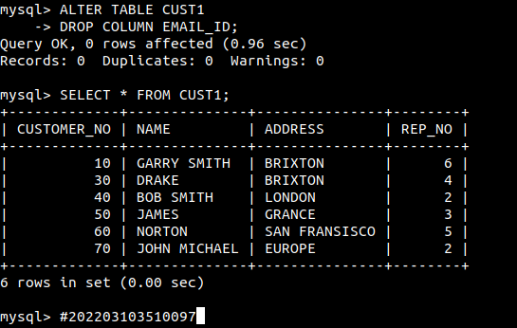

10) Delete all the data rows from cust1 and look at the contents again.
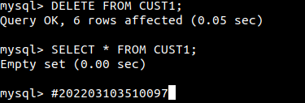

11) Delete the table cust1 and then try to look at its contents again.
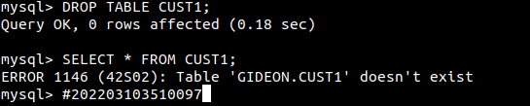

12) List the customer numbers (customer_no) and names (name) of all customers
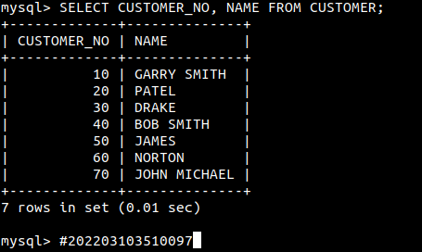

13) List all details of the product with a product number (product_no) of 121 and 136.
(use Or).
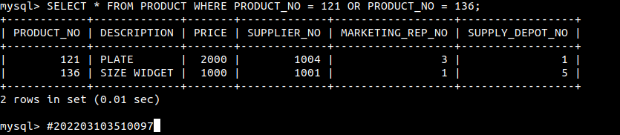

14) List all details of depots with rep 5 as their rep(rep_no).
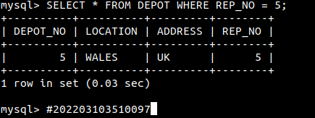

15) List the product number (product_no) and description only of all products from supplier
number 1005 (supplier_no).
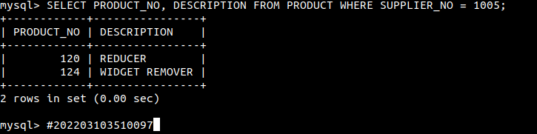

16) List the sales rep number (rep_no), depot number and address for depots located at NORTH and address is UK.
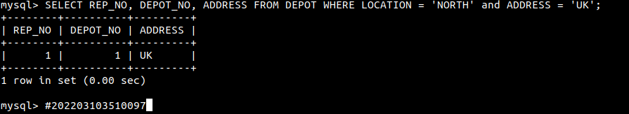

Conclusion: SQL is a fundamental tool for managing databases, enabling the creation, modification, and retrieval of data. DDL commands are used to define the structure of the database, while DML commands handle data manipulation. By following best practices and understanding the core concepts of SQL, developers can create efficient, organized, and secure databases that cater to their data management needs.

